# Lab Number: 01 Date: 2025/06/13

# Title: Understanding the basic Network Equipment

# THEORY:

## NETWORK EQUIPMENT

For a computer network to function, it will require several networking devices or hardware to coordinate with each other and give us a well-functioning internet. For example, Repeater, Hub, Bridge, Switch, and NIC, etc.

1. **Repeater:**

A repeater is a device that amplifies a signal as it passes though it, to counteract the effects of attenuation.

**Function:**

When data enters the hub though any of its ports, the hub regenerates the weak or corrupted signals and transmits it out through all of the other ports. The star topology connectors regenerate the signal when it becomes weak by copying it bit by bit and connecting as per the original strength. It is a 2-port device.

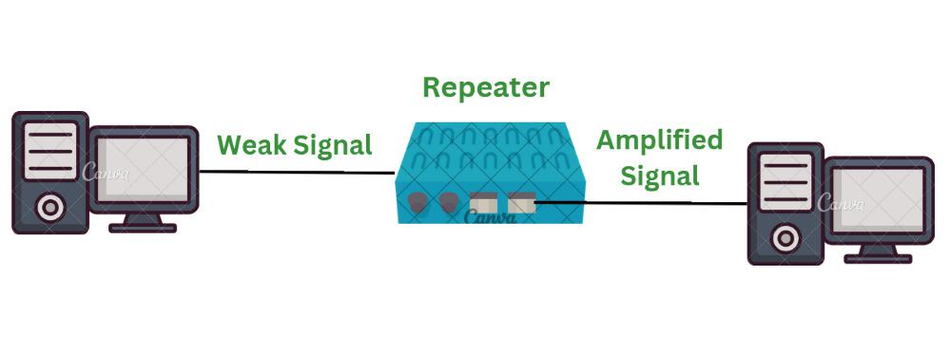

*Fig: Repeater*

1. **Hub:**

A hub is a common connection point for devices in a network which works at physical layer and hence connect networking devices physically together.

**Function:**

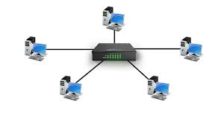When data packets arrive at hub, it broadcast them to all the LAN cards in a network and the destined recipient picks them and all other computers discard the data packets.

*Fig: Hub*

1. **Switch:**

A switch is an intelligent device that works in the data link layer which is capable of own decision making.

**Function:**

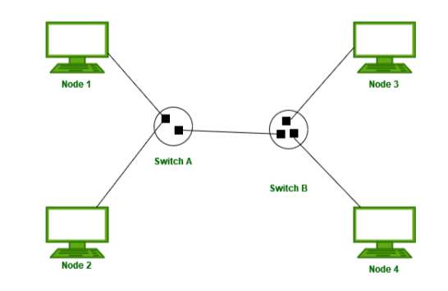It is able to read the MAC address of each frame it receives which allows it to repeat incoming data frames only to the computer or computers to which a frame is addressed which speeds up the network and reduces congestion.

*Fig: Switch*

1. **Bridge:**

Bridges builds the connection with the other bridge networks which use the same protocol.

**Function:**

It is used to join two network segments together; it allows computers on either segment to access resources on the other.

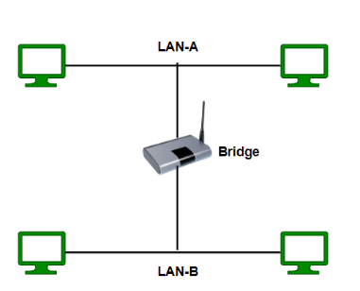

*Fig: Bridge*

1. **Router:**

Router is a networking device used to extend networks by forwarding packets from one logical network to another.

**Function:**

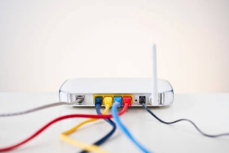It moves packets between networks using their logical addresses (IP). Routers examine incoming packets to determine the correct target IP address and send the packet to that address. Routers typically connect LANs and WANs

*Fig: Router*

1. **Modem:**

Modem is a hardware device that allows a computer to send and receive data over a telephone line or cable or satellite connection. It enables a computer to transmit and receive data over telephone lines by modulating and demodulating signals.

**Function:**

The main function of router is to do sorting and the distribution of the data packets to their destinations based on their IP addresses.

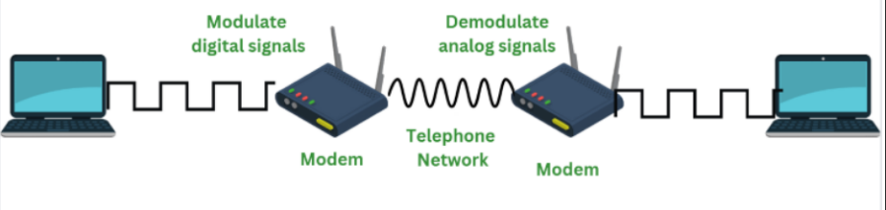

*fig: Modem*

1. **Firewall:**

In network, a firewall is a network security system that monitors and controls incoming and outgoing network traffic based on predefined rules.

**Function:**

It typically establishes a barrier between a trusted network and suspicious network

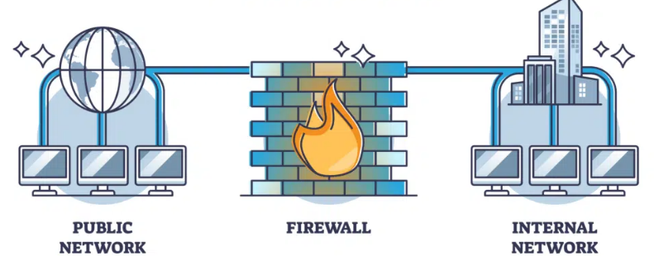

*Fig: Firewall*

1. **Wireless Access Point (WAP):**

WAP is a device that creates a wireless local area network, or WLAN, usually in an office or large building. A WAP is a hardware device on a LAN that allows wireless capable devices and wired networks to connect through a wireless standard, including Wi-Fi or Bluetooth.

**Function:**

It connects to a wired router, switch, or hub via an Ethernet cable, and projects a Wi-Fi signal to a designated area. It features radio transmitters and antennae, which facilitate connectivity between devices and the Internet or a network.

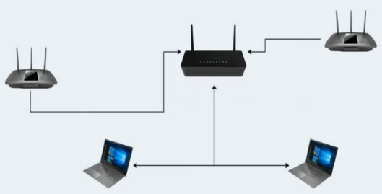

*Fig: WAP connected with router*

1. **VOIP Endpoint:**

Voice over Internet Protocol (VoIP) refers to the standards or protocol that facilitate voice-based calls using internet connection instead of using tele-service.

**Function:**

It enables voice communication over the internet, effectively turning voice calls into digital data packets that can be transmitted like any other data. It converts your voice into a digital signal, compresses it, and sends it over the internet and allows you to make calls using a broadband internet connection instead of a regular(or analog) phone line.

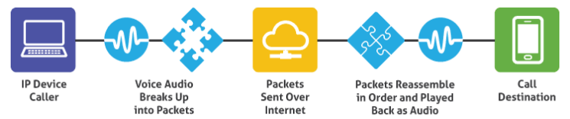

*Fig: VOIP*

1. **Network Interface Card (NIC):**

The NIC provides the physical connection between the network and the computer.

**Function:**

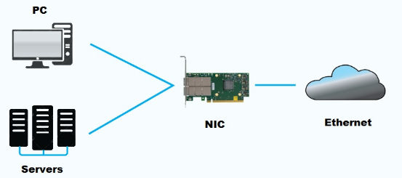It acts as an intermediary, enabling devices to send and receive data over a network, whether wireless or wired.

*fig: NIC*

## Conclusion:

In this practical, we explored various networking equipment along with their crucial role in making network function well. The learnings emphasized the importance of network infrastructure and device functions which makes possible for us to use internet in our day-to-day life. Furthermore, it has made us know the importance of different network equipment’s for different scales, topology, etc.